EPSCoR Survey Design Workshop
Western EcoSystems Technology, Inc.
University of Wyoming
April 2, 2026

SAMPLING TERMS
- Target population: The complete collection of units to which inference is made
- Sampling frame: The list of sampling units. In the example, the sampling frame would be the list of all reaches in the watershed.
- Sample: A subset of a population. This may be chosen through a random, probabilistic mechanism (random sampling) or nonrandomly (judgment sampling)
- Sampling unit: The unit actually sampled. For example, we may want to survey all redds in the four basins, but we do not have a list of all redds by basin. Reaches are used as the sampling units.
- Sampled population: The collection of all possible sampling units that might have been chosen from a sample. This is the population from which the sample was actually taken.
- Response unit (or observation unit): The object on which the measurement is taken. This is the basic unit of observation. Redds will be the response/observation units within selected reaches.

NOTATION
Y = outcome of interest
τ = population total
μ = population mean
N = population size (finite domain)
|R| = population size (continuous domain)
n = sample size
n’ = number of target units in the sample
m = number of responding units in the sample

EQUATIONS
Inclusion probability for a SRS: $π_{i}=\frac{n}{N}$
Design weight for unit i: $w_{i}=\frac{1}{π_{i}}$
Horvitz-Thompson Estimator:
$$\hat{τ}=\sum_{i=1}^{N}{\frac{{Z_{i}y}_{i}}{π_{i}}}=\sum_{i=1}^{n}{\frac{y_{i}}{π_{i}}}=\sum_{i=1}^{n}{w_{i}y_{i}}$$

$$\hat{μ}=\frac{\hat{τ}}{\sum_{i=1}^{n}{w_{i}}}$$

Generalized ratio estimator: $r= \frac{\sum_{i=1}^{n}{w_{i}y_{i}}}{\sum_{i=1}^{n}{w_{i}x_{i}}}$, ${\hat{μ}}_{r}=rμ_{x}$, ${\hat{τ}}_{r}=rτ_{x}$

Regression estimator: ${\hat{μ}}_{G}={\tilde{μ}}_{y}+B\left(μ_{x}-{\tilde{μ}}_{x}\right)$

REQUEST FOR PROPOSAL
Estimating Chinook Salmon Escapement
Purpose: The purpose of this project is to provide statistical support to develop survey and analysis methods to estimate the number Chinook salmon redds of transported anadromous fish by watershed in the upper North Fork Lewis River area upstream of Swift Dam.
Background: Swift Dam on the North Fork Lewis River in south central Washington does not have adequate fish passage infrastructure for anadromous fish, so fish are collected below the dam and trucked above the dam to be released. This project is developed to monitor the use of available habitat above the dam for spawning. Because the fish are trucked above the dam, the number of females available to spawn is known.
The sampling frame is provided in Figure 1 and the number of miles per basin is provided in Table 1.
Scope of Work:
- Develop a survey design. Develop a survey design that incorporates a GRTS sample of points for annual redd surveys by field crews.
- Outline analysis approach. Develop an analysis approach that will facilitate the estimation of the total number of redds and the proportion of spawning females above Swift Dam. State your assumptions.

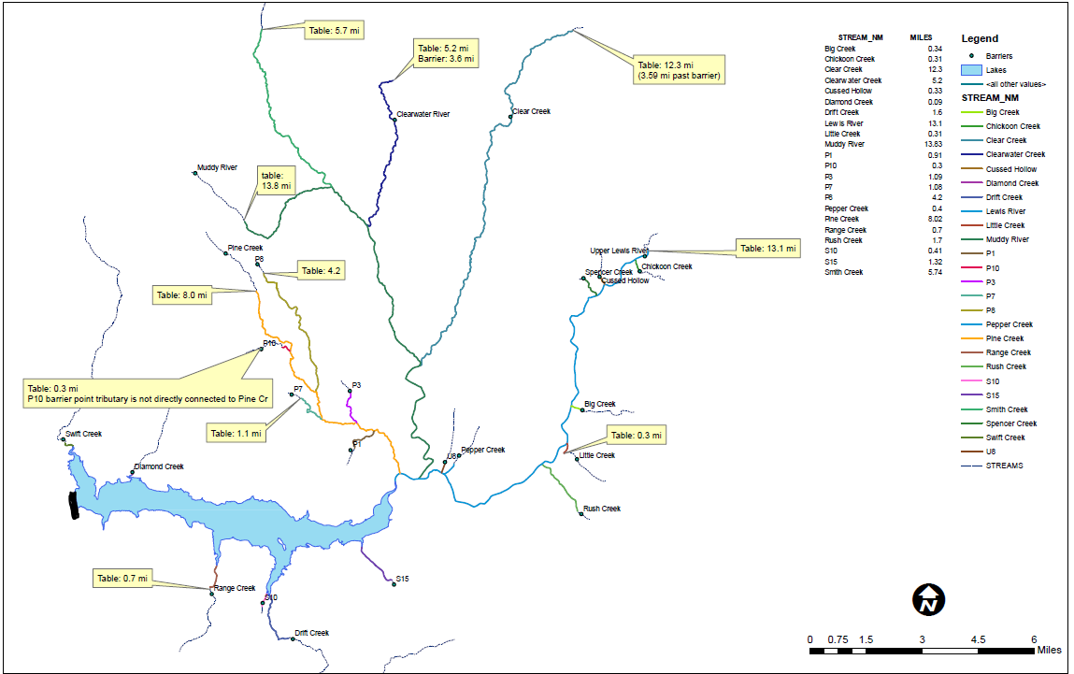
Figure 1: Swift Reservoir, Swift Dam (black bar), and North Fork Lewis, Muddy River, Pine Creek and Swift Creek watersheds.
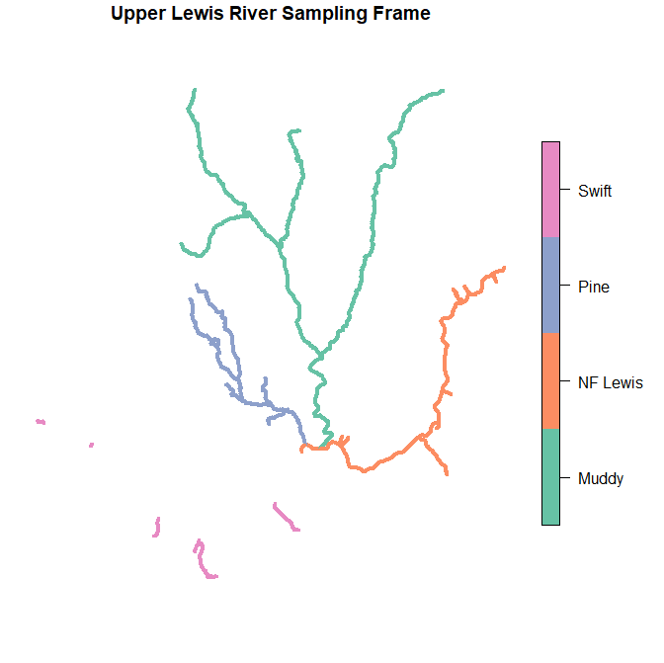
Figure 2: Swift Reservoir, Swift Dam (black bar), and North Fork Lewis, Muddy River, Pine Creek and Swift Creek watersheds.

Table 1: Length of accessible stream by watershed and stream
Watershed

